For questions about this form contact:
KSU Institutional Biosafety Committee
http://research.kennesaw.edu/ibc/contact
Email: ibc@kennesaw.edu Phone: 470-578-4941

Version August 2019
Institutional Biosafety Committee
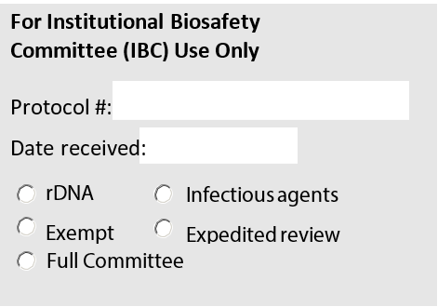
Protocol Review Form for Teaching Use
Signature of Course Coordinator | DATE
Signature of Department Chair | DATE
Signature of IBC Chair | DATE
Signature of Biosafety Officer | DATE

College: ____________________________________________ Dept. ______________________________________
Course name: _______________________________________ Course number: _____________________________
Course coordinator: __________________________________ Phone #: ___________ Email: _________________
Lab coordinator: _____________________________________ Phone #: ___________ Email: _________________
Lab location: ________________________________________ Prep room location: ___________________________
Long-term storage location: ____________________________

Name of the biological material | Typeª | BSL^{b} | Source of the material^{c}
ª: Type can be indicated by M (microbe), T (toxin), P (plant), A (animal), D (recombinant DNA), or O (other, must specify).
^{b}: BSL stands for biosafety level. BSL-1: non-infectious; BSL-2: infectious.
^{c}. Vendor, field isolate, clinic isolate, or generator’s name.

Please attach all related Standard Operating Procedures (SOPs), Written Lab Exercises or Safety Protocols
Note: Insert more rows if needed.

